**Assignment – 2**

1. Create three instances, install nginx and apply ALB (Application Load Balancer) :

Step – 1 : Open Aws and search for EC2 and we can see security group on the left. Now we need to open security group and need to create security group.

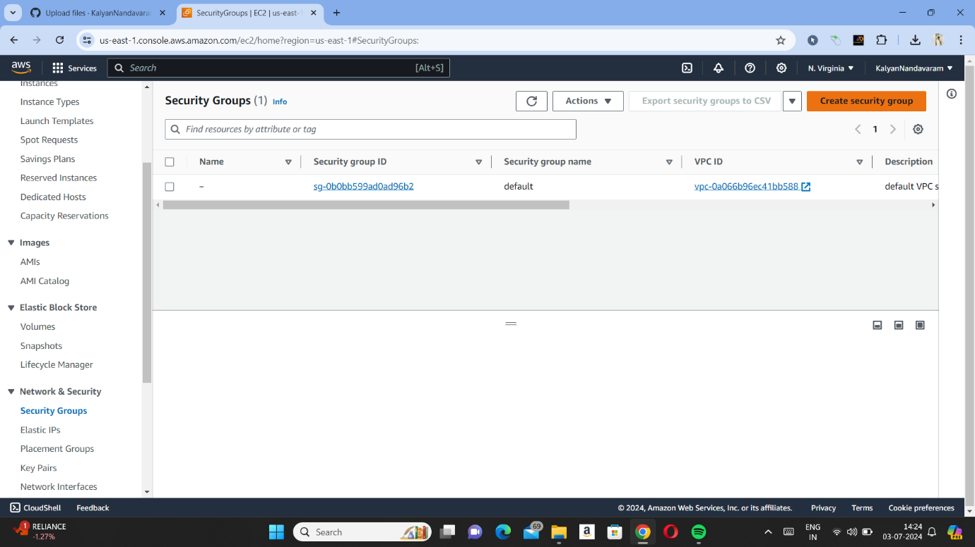

Step – 2 : Now we need to give name of the security group and in description we need to enter allow and vpc we are giving as default.

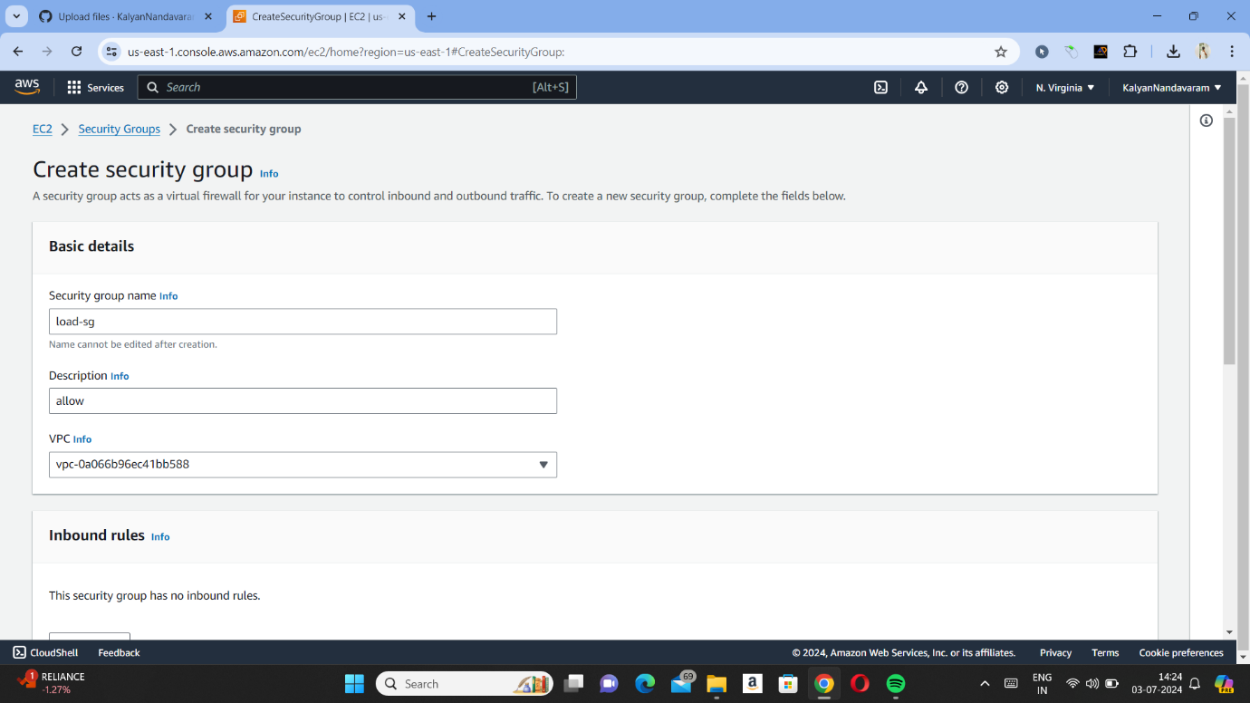

Step – 3 : Now we need to add inbound rules in one inbound rule we need to select type as HTTP and source as 0.0.0.0/0 and in another rule we need to select All traffic and source as 0.0.0.0/0. Now we need to press on create security group.

Step – 4 : Now we need to open instances which we can see on the left side and we need to launch an instances.

Step – 5 : Now we need to give name of the instance and need to create a key pair.

Step – 6 : Now we need select subnets and need to select existing security group as we have created in step – 2 and need to launch instance.

Step – 7 : After creating one instance, now we need to launch two more instances same as above steps with different available zones (subnets).

Step – 8 : Now we need to open instances one by one and need to connect and need to install nginx. Now we are opening first instance and connecting it by pressing connect and need to copy SSH link.

Step – 9 : After copying SSH link now we need to paste it in Gitbash and need to type sudo – i to become root user.

Step – 10 : Now we need to install nginx by typing ‘yum update -y’ and ‘yum install nginx -y’ now nginx will be installed.

Step – 11 : Now we need to open html and need to remove index.html file and we need create a file as index.html and need to give our own data and need to type ‘systemctl restart nginx’ to restart nginx, so that we can get our data in web.

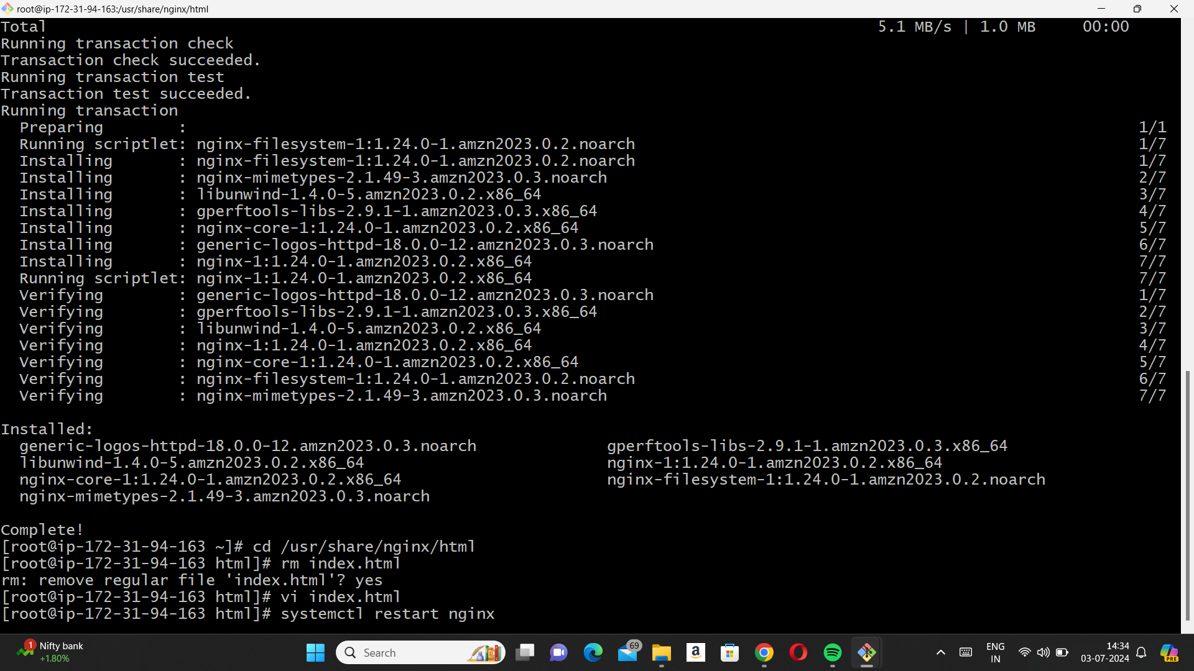

Step – 12 : Now if we copy IPv4 address and paste it in URL then we will get our data which we gave in step – 11.

Step – 13 : Now we need to create a target group by pressing target group on the left and need to press create target group and now we need to give the name for target group and now we need to scroll down and press next.

Step – 14 : After pressing next we need to select three instances which we have created in step – 4 and need to press include as pending below and press create target group.

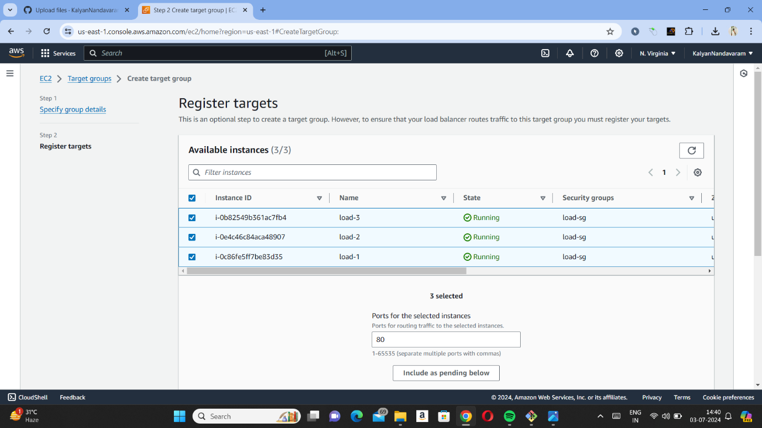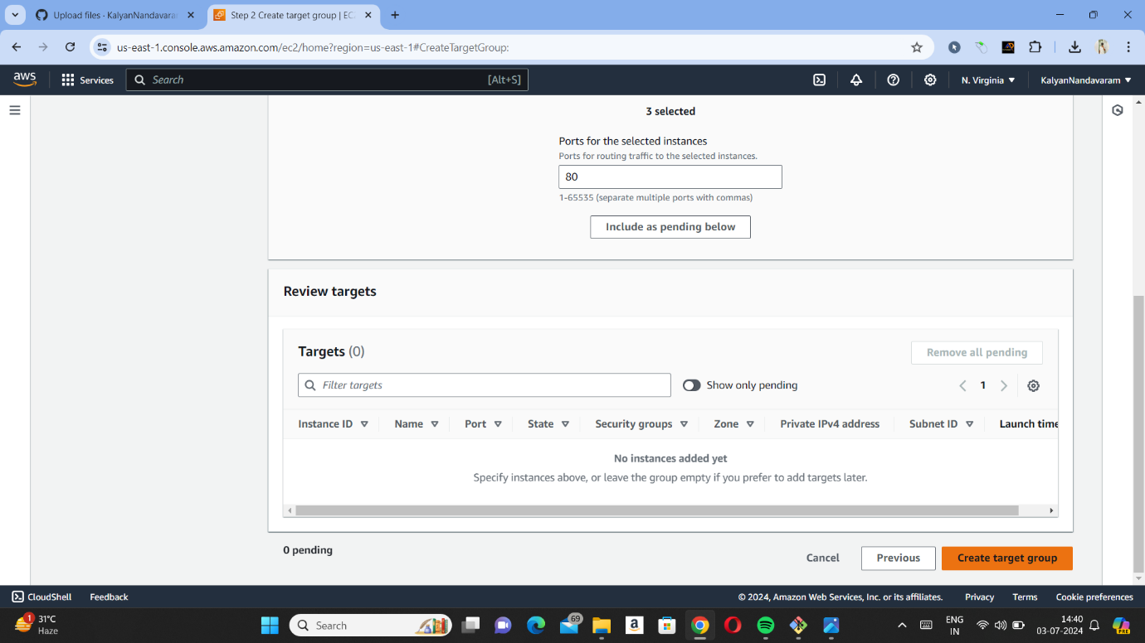

Step – 15 : Now we need to select load balancer which is on the left side and need to select create load balancer. Now we need to select Application Load Balancer.

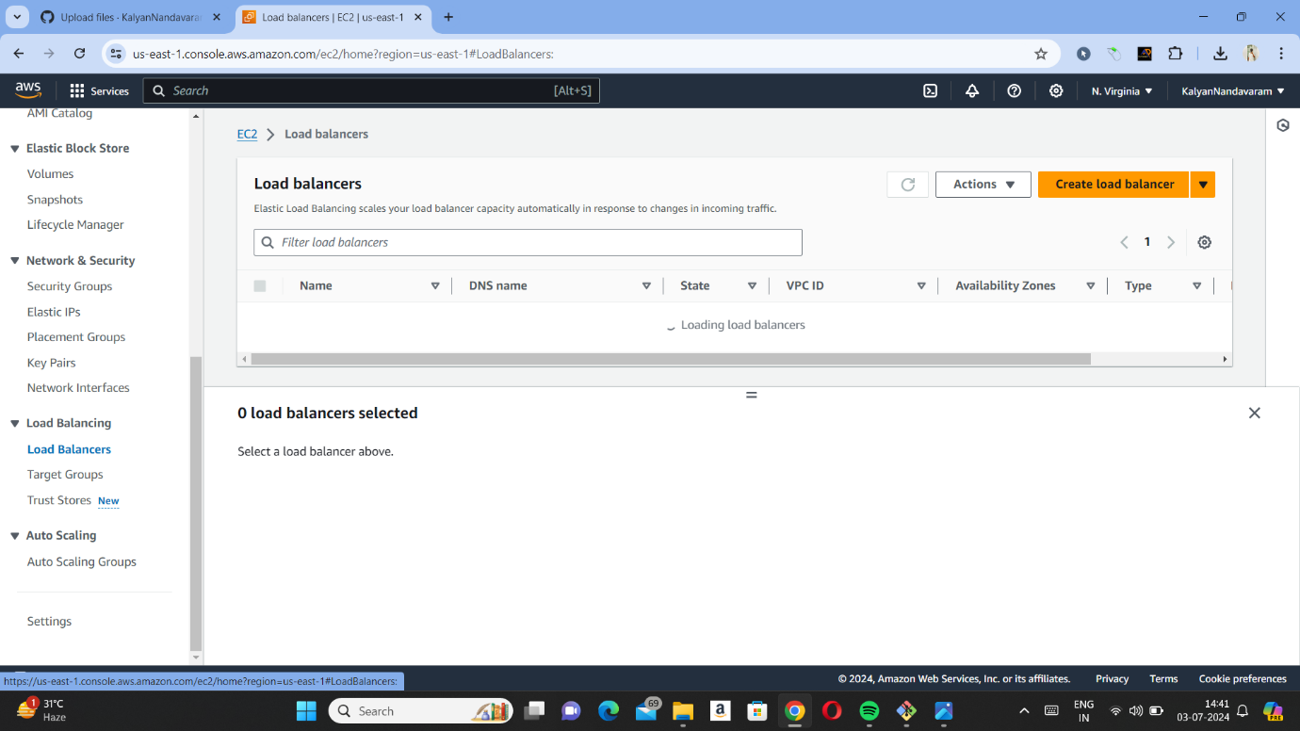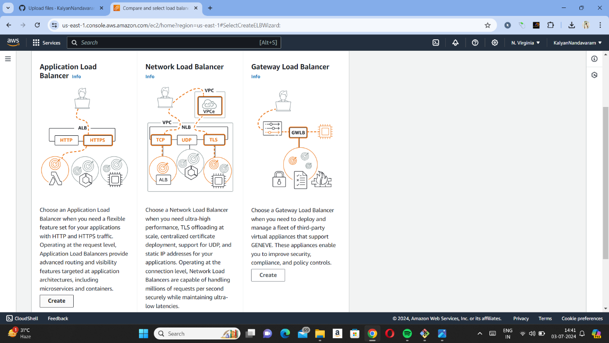

Step – 16 : Now we need to give name for load balancer and need to select subnets in mapping which we gave in instances.

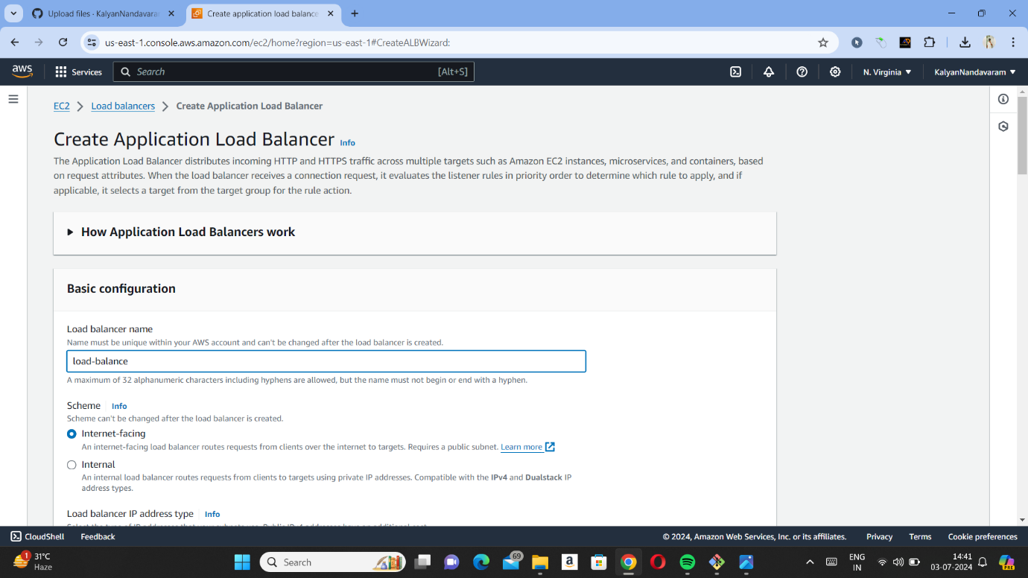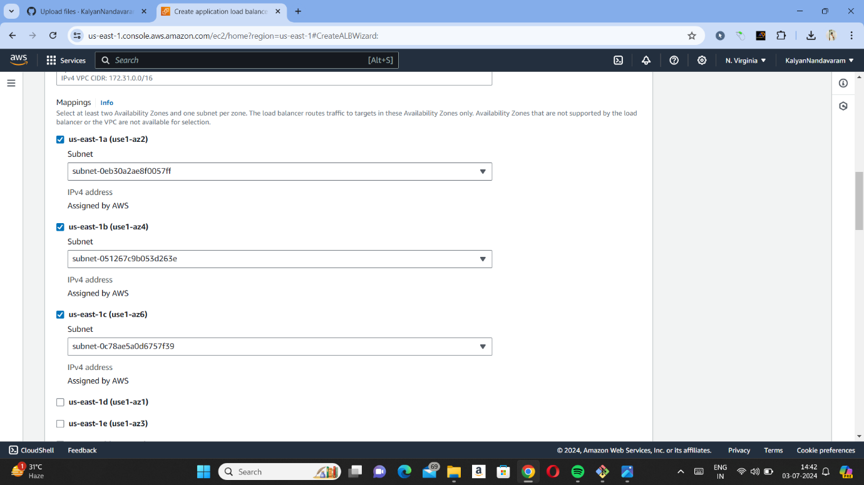

Step – 17 : Now we need to remove default security group and need to add the security group which we have created and need add target group as well and need to scroll down and select create load balancer.

Step – 18 : Now we need to open load balancer which we have created in above steps and need to select DNS link. If we paste that link in URL we will get our data which we added in index.html.

